Case Study 4. Ecuador: Food security challenges from natural and man-made disasters
Abstract

Ecuador has been chosen as a case study, to illustrate food security concerns of a Latin American country assailed by major natural disasters, including floods and drought, together with major challenges regarding economic access to food by its own population and the huge refugee population which it hosts. This represents a treble threat to economic and social development and national political stability. Ecuador faces one of the highest chronic undernutrition (stunting) rates in the LAC region, that for children under-five being around 26 percent. In the face of this, the government has maintained the dual goals of strengthening the productive base and eradicating poverty, with inward investment made possible mainly by oil sector revenues. This case study deals with the challenges more than the solutions.
Key words: drought and flood and climate change; economic access; undernutrition; Columbian refugees; poverty and unemployment; smallholder; safety net
4.1. Introduction
Ecuador rarely features in news items carried by satellite TV news channels. Like Belize in Central America (see case study 3 above) events which occur there do not normally attract international media attention. That its territory encompasses ‘Darwin’s’ Galápagos islands, some 1,000km off the coast, is perhaps Ecuador’s main de facto claim on the attention of the world’s general public. The ‘norm’ of Ecuador is not on the main agenda of international public attention, though it deserves to be, for both its beauty and its challenges, some of the latter being discussed below.
The country straddles the equator on the western side of South America (Map 4.1 below). Peru borders the country to the south and east, and Columbia to the north. As seen in the relief map, The Andes run approximately north-east south-west through the center of the country dominating La Sierra region, separating La Costa region bordering the Pacific Ocean and La Amazonia to the east of the mountain range. La Amazonia comprises the Amazon forest, having less than 5 percent of the country’s population, yet supporting the whole country indirectly. Two thirds of the country’s population reside in urban areas in other parts of the country. The 2001 census of Ecuador shows a 12.4 million population, with 77.4 percent being of mestizo ethnicity, 10.5 percent white, 6.8 percent indigenous and 4.9 percent Afro-Ecuadorian. Data from the more recent census conducted in 2010 is not readily available.
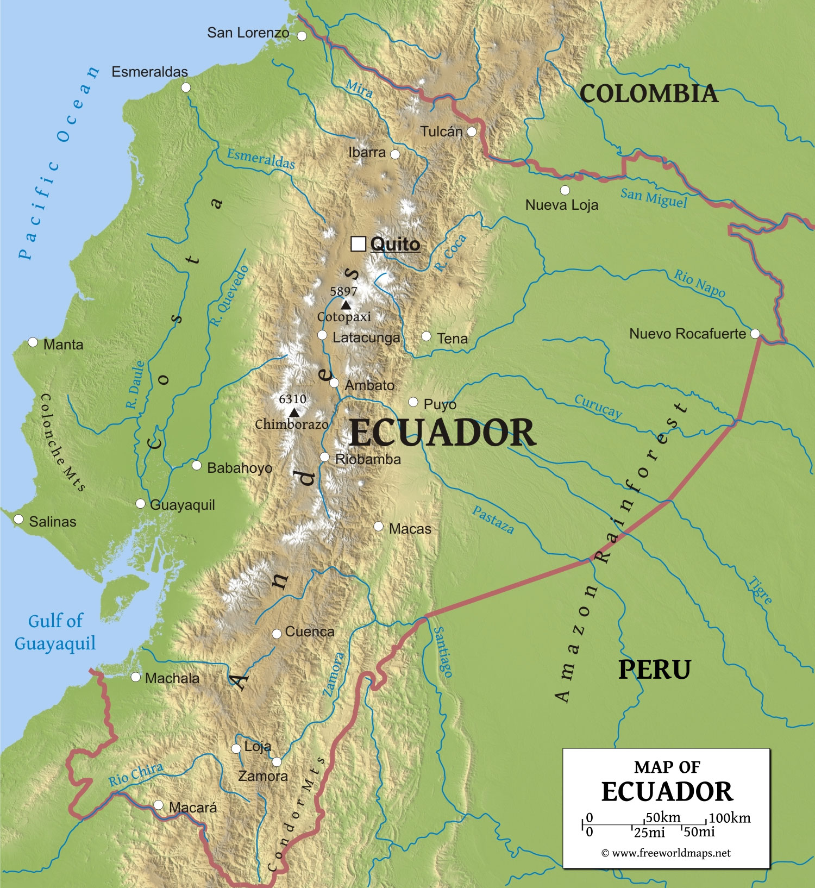
Map 4.1. Relief map of Ecuador, South America (with permission www.freeworldmaps.net)
Overall, Ecuador is categorised as a low middle income country by the IMF. The Gini Coefficient of 47.9 (UNDP, 2010), however, underscores the difference in wealth within the country, in which the richest 10 percent of the population amasses 43.3 percent of total income whilst the poorest 10 percent earns only 1.4 percent. This results in the inequality and exclusion which dominate social problems in the country, despite progress over recent years.
Large swathes of Ecuadorians live in the shadow of severe food insecurity. This is caused in part by an array of natural disaster risks, including floods, tsunamis, drought, earthquakes, landslides and volcanic eruptions (D’Ercole, 2005). For instance, in 2009 Ecuador experienced its worst drought for the previous 45 years, whilst heavy rain and floods affected 110,000 people from January to April 2012. Over-exploitation of mountain slopes through deforestation and replacement cropping, and over-grazing of highland pastures is leading to surface erosion (see photos below).
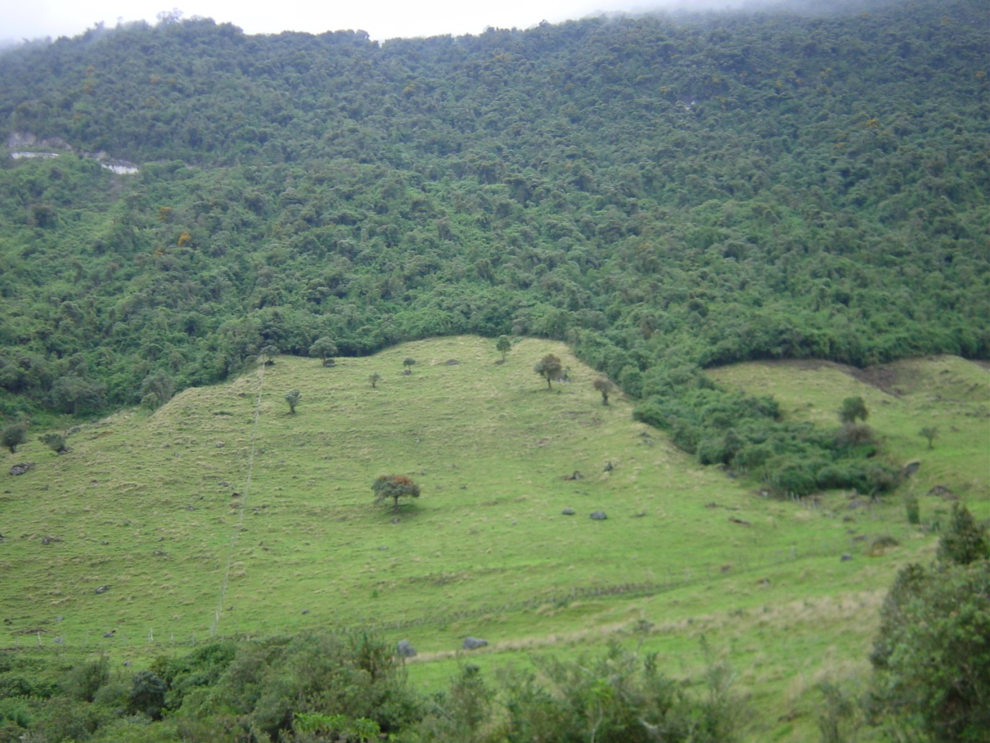
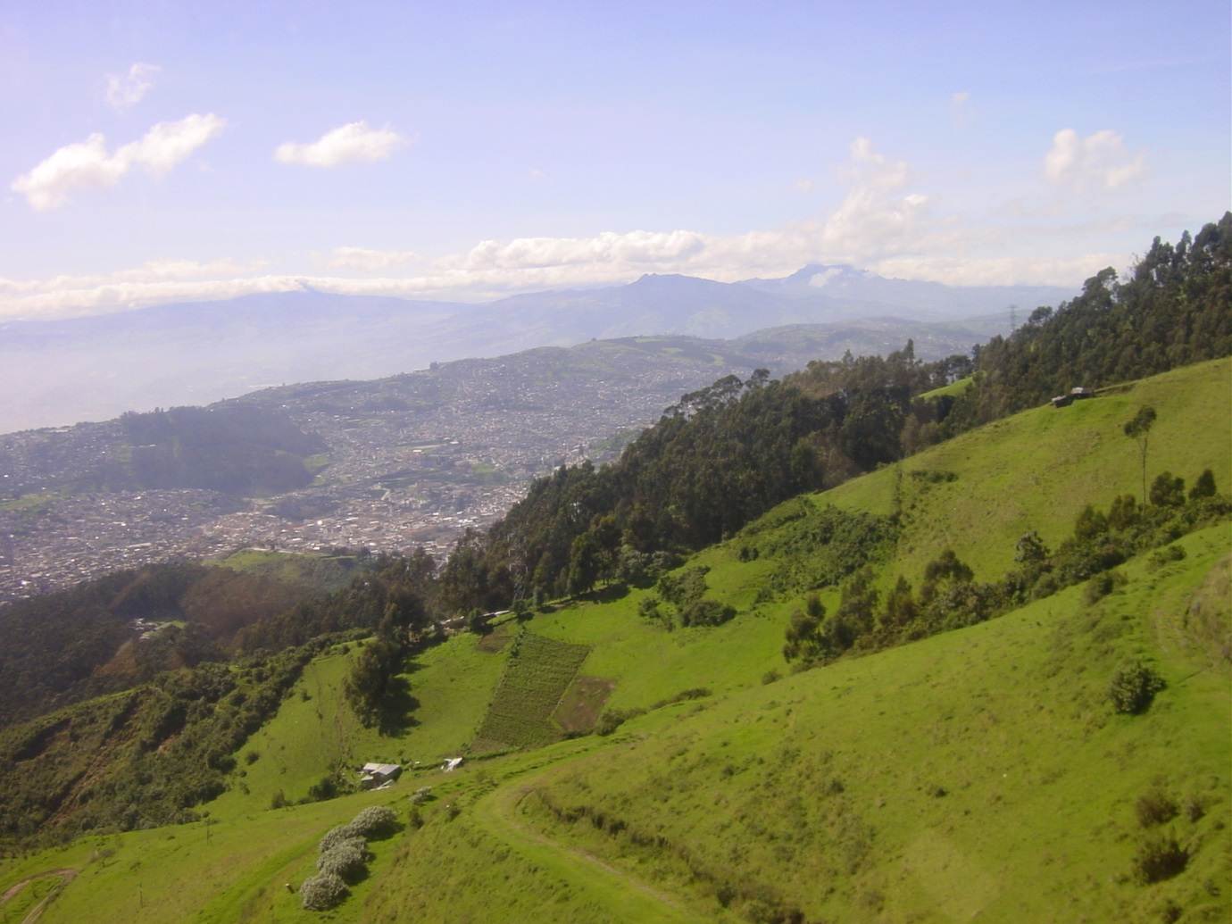
Photos 4.1 and 4.2. Grazing and farm encroachment on the indigenous mountain forest, on the outskirts of the capital Quito, seen here lower down the escarpment at almost 3,000m (photographs by Gino Henry).
Because of its fragile ecosystems, climate change events, including a drying of the eastern part of the country and increased precipitation in the west, are increasing the level of risk of food insecurity for marginalised populations. Studies undertaken since 1970 show that glaciers in the Ecuadorian Andes are significantly retreating and montane moorlands deteriorating, both undermining the ability of montane ecosystems to regulate water supply over the year, directly affecting agricultural productivity and production, and hence food and nutrition security (WFP, 2012).
Over the decade 2000-10, Ecuador has incurred economic losses of around US$4 billion from droughts alone, together with additional losses due to other natural disasters, altogether totalling $US5.18 billion. It is clear that over that decade, Ecuador has suffered more economic damage from these disasters than any of the other eight Latin American countries mentioned by WFP (2012) ibid. in its Country Strategy (Table 2, page 11). Its nearest rival, in terms of damage sustained, is Brazil, which has an almost 200m population, so the loss on a per head basis for Ecuador is considerably more. In the more recent heavy rains in 2012, an estimated US$70m of damage was caused by coastal flooding alone (MALFA, 2012).
As indicated by the Gini Coefficient discussed above, there is a wide wealth gap in the country, with many at the impoverished end of the spectrum having insufficient economic access to the food that they need. Through its national framework for development, the National Plan for Good Living 2009-13 (Buen Vivir), the Ecuadorian government is committed to social inclusion and equitable distribution of resources and means of production, in recognition that national security is a development priority, and that this includes food sovereignty and food security. Through the United Nations Development Assistance Framework (UNDAF), the UN supports the Buen Vivir Plan, with several focus areas which include poverty reduction, and food sovereignty and food/ nutrition security of vulnerable people.
Whilst the economy of Ecuador is robust with strong growth trends, Ecuador has one of the highest incidences of undernutrition in the Latin America and Caribbean region. Chronic undernutrition affects some 26 percent of the population, and in some rural indigenous ethnicity populations, up to 92 percent of children under-five can be so affected. One of the reasons for impoverishment of citizens is the refugee population which Ecuador hosts, as a result of the drug scene and political instability in neighboring Columbia to the north. Indeed, Ecuador has more refugees and asylum seekers than any other country in Latin America, most from Columbia who infiltrate mainly the northern border. The rate of Columbian refugee migration is also increasing in the southern provinces of Ecuador, such as Azuay and Guayas. In 2011, Ecuador hosted the seventh largest number of refugees in the world, over 100,000, with more than half of them officially recognised and registered (WFP, 2014), and some three quarters being women and children. Martinez et al. (2009) believes that the internal armed conflict in Columbia has created the most complex refugee situation in the Western Hemisphere (Box 4.1). An annual growth rate of 20 percent in the people requesting asylum is noted, so the influx is increasing exponentially.
Box 4.1. Columbian refugees in Ecuador
Columbian refugees have fled from violence – including murder, death threats and persecution, extortion, disappearances, internal displacement and forced recruitment, all of which characterize the internal conflict in Columbia. The refugees arrive without financial assets. Even once in Ecuador, they are still highly vulnerable, and in 2010 more than 120 refugee camps in the north were dismantled by the Ecuadorian army. Executions within the camps are commonplace.
The Columbian refugee population is heterogeneous and has limited informal networks whereby they might find licit work and seek protection and assistance. International visibility of Columbian refugees is less than it might be because many refugees do not live in camps, but have diffused throughout 10 of the 24 provinces in Ecuador. Many live in urban areas in provinces like Pichincha (where the capital Quito is located). Many choose not to register their presence due to actual or perceived discrimination, and so receive no legal documentation relating to their presence. A significant proportion becomes involved in nefarious activities to try to earn a living, smuggling of arms and drugs, human trafficking and money laundering. The unregistered are unable to open bank accounts, or access health services or national safety net programs, which contributes to their high levels of exclusion, inevitably leading to poverty together with food and chronic nutrition insecurity. Consumption by these refugees of vegetables, fruits and protein-rich foods is rare, owing to their relatively high cost.
All the refugees are at risk from adolescent local gangs, who can be highly xenophobic against Columbians, in part because of the extra competition they have brought to the local labor market, and the increased pressure on basic and social services. Especially the women are under threat of physical insecurity and sexual exploitation. Armed groups related to the lucrative drug trade in Columbia operate either side of the common border too. Agents of the Columbian government also infiltrate the border, with their own intimidatory behaviour against those who witnessed excesses of the Columbian security forces before they fled.

4.2. Indicators of food security in Ecuador
4.2.1. Food availability
FAOSTAT shows that Ecuador is largely self-sufficient in essential commodities, with a healthy agricultural export portfolio. The main exception is that there is a modest shortfall in corn production, and local wheat production does not reach the demand for its processed products, though there is a government drive to encourage increased production in the northern and central highlands. Soya cake and grain feeds for livestock are also imported to supplement local production.
4.2.2. Food Access and poverty
As mentioned above, income disparities prevalent in the country result in serious food access problems for the poorer strata in society, both economic and the physical access/ distribution to remote communities. Macro-economic effects, in the form of the ongoing international food price rise, a significant decrease in remittance inflows since the 2008 financial crisis struck (IDB, 2009), and unpredictable in-country weather have also played a role in decreasing food access for the poor in Ecuador. Food prices reached an all-time high in Ecuador in early 2011, to which the government responded by increasing the minimum monthly salary to US$264, though this was still less than half of the cost of an adequate monthly food basket valued then at US$541. This move, together with others by the government, forestalled the food price riots which happened in some other countries in Latin America.
The World Bank’s Ecuador Poverty Report of 1995 states that, although the oil boom of the 1970s led to unprecedented growth, poverty remained pervasive. The report says “The distribution of wealth is highly skewed, and close to four million Ecuadorians, about thirty-five percent of the population, live in poverty. Another seventeen percent are vulnerable to poverty. One and a half million Ecuadorians live in extreme poverty and cannot meet their nutritional requirements even if they spend everything they have on food. Poverty is higher in rural areas, where two out of three poor people live”.
The same report stressed that the characteristics of rural and urban poverty are quite different. Rural poverty is associated with lack of education, little access to land, a low degree of market integration, and lack of employment in the vibrant off-farm rural sector. Furthermore, poverty among the many indigenous people, who live predominantly in the rural highlands (Sierra) and the Amazonia region, is much higher than for the non-indigenous population. Indigenous groups also show alarming levels of undernutrition and child mortality, and receive far less education than the non-indigenous population.
By contrast, urban poverty, which affects one and a half million people, is linked to a somewhat different set of variables, which are region-specific. For example, while basic service provision had reached the poor in the urban Sierra, many poor in the urban Costa are without a functioning water supply or sewage system. Yet the poor in the various urban areas have some characteristics in common - low educational achievement, employment predominantly in the informal sector, rented rather than owned housing, and low rates of labor force participation by the spouse of the household head.
Since the Report of 1995, the World Bank conducted another poverty assessment published in April 2004, and continually updates its country overview website for Ecuador (World Bank, 2014c). After winning another four-year term in February 2013, President Rafael Correa has maintained the dual government goals of strengthening the productive base and eradicating poverty, with inward investment made possible mainly by oil sector revenues, from about half a million barrels crude production per day since 2007, about a third of which destined for USA (EIA, 2014), and natural gas. According to the World Bank, between 2006 and 2013, income poverty (using the national poverty line) fell from 37.6 percent to 25.5 percent of the population, and extreme poverty declined from 16.9 percent to 8.6 percent. Moreover, inequality decreased faster than the average for the region, the Gini coefficient falling from 54 to 48.5 over the same seven-year period. This was because income growth most benefited the poorest citizens. Between 2000 and 2011, the highest growth in income occurred in the poorest two quintiles of the population. Income of the poorest 40 percent of the population rose 8.8 percent compared with 5.8 percent for the average for the total population. The World Bank cautions, however, that significant challenges remain in terms of the sustainability of these achievements in reducing poverty and inequality, and in ensuring sustainable, inclusive growth. More than half of the Ecuadorian population continues to live in poverty or is vulnerable to again falling below the poverty line.
In its Human Development Report of 2010, UNDP points out that only 66.2 percent of the Ecuadorian population has formal employment, the unemployed being particularly vulnerable. The urban poor spend almost 52 percent of their income on food. WFP (2012) op. cit. points out that Columbian refugees and other migrants, indigenous and Afro-Ecuadorian populations who constitute most smallholder farming families, are concentrated in the poorest socio-economic quintile, and their income sources are erratic. They suffer disproportionately from chronic undernutrition, especially iron deficiency anaemia. Smallholders have little or no access to investment capital, improved farming technologies or markets and are forced to sell their produce at low prices to middlemen.
4.2.3. Undernutrition
The WFP country Strategy (WFP 2012) op. cit. warns that though the country is likely to meet its MDG1 target of halving the 1990 rates of underweight children by 2015, Ecuador faces one of the highest chronic undernutrition (stunting) rates in the Latin America and Caribbean region (after Guatemala, Haiti, Bolivia and Honduras). The chronic undernutrition rate for children under-five is around 26 percent. Ecuador also exhibits a large number of adults with micronutrient deficiencies. Map 1 on page 8 of the WFP Strategy shows that the prevalence of undernutrition for children under-five is not spread evenly across the country. The >30 and >40 per cent categories are not in the coastal lowlands (with the exception of Santa Elena Province to the north of the Gulf of Guayaquil) but in the Andean uplands and the rainforest area to the east of it.
Furthermore, levels of anaemia in Ecuador are one of the highest in the LAC region, at 58 percent of children under-five (Martinez et al. 2009) op. cit., this related to a diet which is rich in cereals and low in animal products, compounded with intestinal parasites contingent on poor sanitary conditions, and low birth weight which predisposes children to morbidity and death. These circumstances are amplified in indigenous population areas, due to poverty, social exclusion and local food consumption habits.
4.2.4. Safety nets
WFP and USAID provide much-needed assistance to the food-insecure in Ecuador, through food assistance programs, livelihood support, refugee integration (to diffuse tensions between refugees and Ecuadorian host communities) and nutritional/ feeding programs. WFP provides targeted communities with Food for Work, Food for Assets, and Food for Training that encourage families to purchase diverse and nutritious foods. Food vouchers and transfers allow more flexibility and efficiency in responding to needs. Local purchase and a strong gender focus (through an agreement with UN Women) also characterise the WFP effort, together with training on nutrition, hygiene, safe water and protection of water sources. WFP aims to generate evidence-based food and nutrition security models which are cost-effective and environmentally sound. An evaluation of three food assistance modalities (cash, vouchers and food) in vulnerable urban communities revealed the advantages of the food voucher modality.
WFP’s three-year Protracted Relief and Recovery Operation (PRRO 104430) started in July 2011 (UNHCR and WFP, 2011), with an emphasis on the border area with Columbia, with beneficiaries expected to number more than 120,000. The Operation is at pains to target not just the Columbian refugees there, but also the marginalised Ecuadorians, so as not to inflame the already-fraught inter-relationships. The Government of Ecuador has rightly insisted that this provision constitutes an over-arching imperative for both WFP and UNHCR. WFP’s Ecuador Country Strategy (2012-2016) (pages 12-41) lays out its strategy and action plan for addressing the constraints listed above, in concert with the government and other partners, and in compliance with the national policy framework and priorities.
USAID’s Food for Peace (FFP) program targets 13,900 Columbian refugees and Ecuadorian host community members in the northern provinces of Ecuador (USAID, 2014).

